Digital Camera D7000
PC Mode Specifications

Rev. 1.00

Nikon Corporation
Imaging Company
Development Department

Table of Contents

1. OUTLINE 3
2. PROCESS FLOW 3
2.1. USB Signal Lines 3
2.2. Finding USB 4
2.3. PTP / MTP 5
3. PC MODE 6
3.1. PC Camera Mode / PC Host Mode 6
3.1.1. PC camera mode 6
3.1.2. PC host mode 7
4. OPERATION ON THE CAMERA 7
4.1. Validity of Operation of Buttons/Dials 7
4.2. Possibility of Menu Item Setting 8
4.2.1. Playback menu 8
4.2.2. Shooting menu 8
4.2.3. Custom menu 8
4.2.4. Setup menu 9
4.2.5. Image editing menu 9
4.2.6. My menu 9
4.3. Available Operations for Functions 10
4.3.1. Shooting operation 10
4.3.2. AF operation 11
4.3.3. Live view 11
4.3.4. Two-button reset 11
4.3.5. Two-button formatting 11
4.3.6. Card operation (playback / deleting images / formatting) 11
4.4. Display Section of the Camera 11
4.5. Auto meter-off delay 12
5. SUPPLEMENTARY MATTERS 12
5.1. Battery Voltage Drop during Continuous Shooting 12

OUTLINE

These specifications define the PC mode as the situation in which the digital camera D7000 (hereinafter referred to as the camera) and the PC are connected by the USB and the USB communication has been established.
Although USB is also used for the connection with the wireless transmitter or the printer that supports PictBridge, this situation is not included in the PC mode.

The following protocol is adopted when connecting with the host in PC mode.
  - PTP/MTP (Image Interface)

For the detailed specifications of the protocols, refer to the specifications below.
- PTP/MTP: D7000 USB Still Image Capture Device Media Transfer Protocol (MTP) Specifications

PROCESS FLOW

This chapter describes the process when the camera is connected with the PC using USB.

USB Signal Lines

USB has the following signal lines.

1) V BUS
2) D+
3) D-
4) GND

- The condition for the camera to detect USB connection
5V current is supplied on V BUS line of the camera.

- The condition for the PC to detect USB connection
D+ line of the PC is pulled up.

Finding USB

In this section, the flowchart of the process on the camera is described when the camera finds USB.

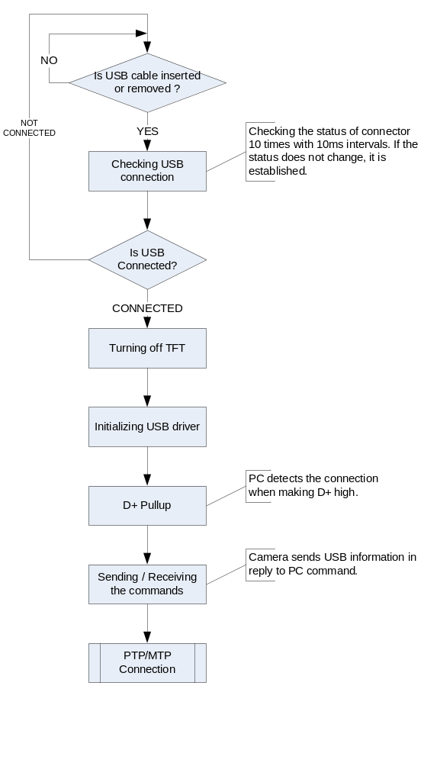

PTP / MTP

The flowchart of the process when the camera is connected in the PTP/MTP mode is shown below.

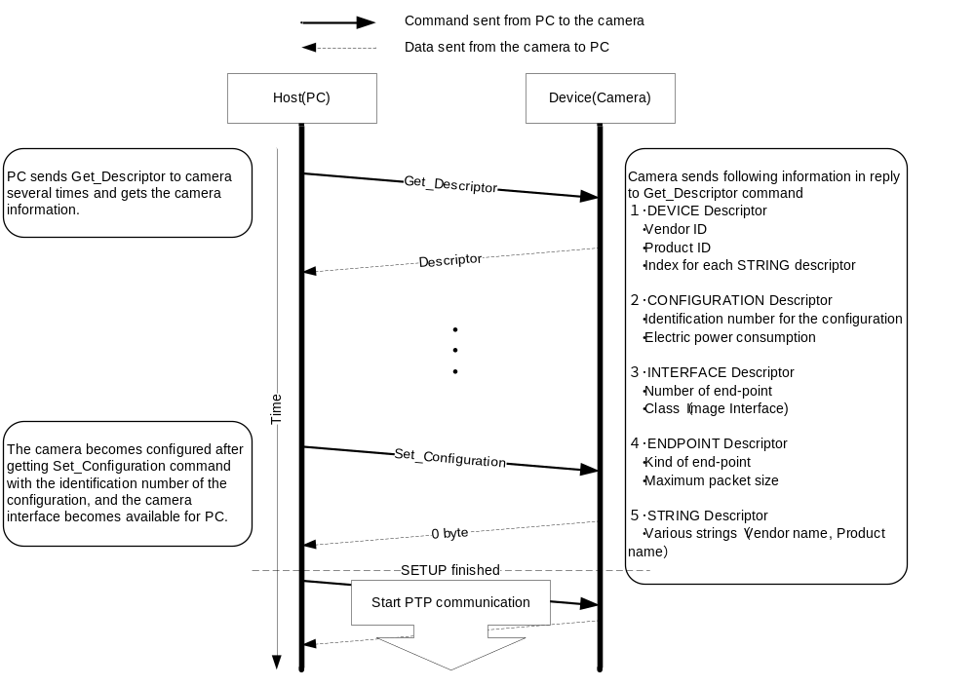

PC MODE

When the camera is connected to the PC with the USB cable, the camera automatically enters the PC mode.
When the USB cable is released, the PC mode is also released automatically.
The timing when shifting to the PC mode changes depending on the status of the camera.

Shifts to the PC mode after the processing is completed in the case below
  - During shooting (AF operation, release operation)
  - During formatting
  - During image recording to the card
  - During access to the card
  - During the preview operation

Aborts the processing and then shifts to the PC mode in the case below
  - During the self-timer operation
  - Two-button-formatting waiting status
  - Preset release waiting status
  - Dust reference release waiting status
  - During the TFT display (menu display / playback display)
  - Mirror-up shooting waiting status (during the mirror-up)
  - During multi-exposure operation
  - During Live view (including the movie shooting)
  - Cleaning mirror-up operation waiting status

The camera does not shift to the PC mode in the cases below.
  - While the cleaning mirror-up operation is being performed
  - While the interval-timer shooting
  - During the firmware updating
  - Battery level “Operation disabled status”
  - During the power interruption (during the power SW-OFF status in the camera)
  - During HDMI-CEC

PC Camera Mode / PC Host Mode

During PC mode, the camera supports PC camera mode (targeted for the camera operation) and PC host mode (targeted for the PC operation), because the available functions on the camera vary depending on the status of use.
  - PC camera mode : This mode is used for the operation by the camera.
  - PC host mode : This mode is used for the operation by the PC.

PC camera mode

This is the default mode during the PTP/MTP connection.
During camera mode, the operation on the camera becomes valid and shooting by the shutter-release button of the camera is enabled (whether the captured image data is recorded to the card or transferred to the PC is described later).
The PC has no control of the operation section on the camera but the acquisition of the status is possible.
The control other than the operation section of the camera (such as the menu items) can be operated by the PC as well.
When the operation section is controlled by the PC in the PC host mode and the mode is switched to the PC camera mode, the control on the operation section made by the PC during host mode is canceled and the information of the buttons/dials on the camera is used.

The camera is switched to the application mode by the request of the PC.
When the camera is switched to the application mode, the function of the playback button and part of the playback menu in the camera can be used.

PC host mode

When the host mode switching request from the PC is made or the command processing from the PC is executed during the PTP/MTP connection, the mode is switched to the PC host mode automatically.
For the automatic switching by the command processing, the mode is switched to the PC camera mode automatically after the processing is completed.
In the PC host mode, the operation of the buttons/dials (except the power switch) or menu of the camera becomes invalid and the operation from the PC becomes valid.

OPERATION ON THE CAMERA

The camera operation differs depending on the PC mode state.

The available operations in the PC camera mode and PC host mode are shown below.

Validity of Operation of Buttons/Dials

Whether the operation of the buttons/dials is valid or not is shown below.

PC mode |  | Camera mode |  | Host mode
Application mode |  | OFF | ON | --
Name of the operation section | Power switch | Valid | Valid | Valid
Name of the operation section | Shutter-release button | Valid | Valid | Invalid
Name of the operation section | Exposure mode button / Two-button reset button | Valid | Valid | Invalid
Name of the operation section | Metering mode button / Format button | Valid (*1) | Valid | Invalid
Name of the operation section | Release mode dial | Valid | Valid | Invalid
Name of the operation section | Operation mode dial | Valid | Valid | Invalid
Name of the operation section | Flash mode button / Flash compensation button | Valid | Valid | Invalid
Name of the operation section | Auto-bracketing button | Valid | Valid | Invalid
Name of the operation section | AFmode button | Valid | Valid | Invalid
Name of the operation section | Focus-mode selector | Valid | Valid | Valid
Name of the operation section | Playback button | Invalid | Valid | Invalid
Name of the operation section | Delete button / Format button | Invalid | Valid | Invalid
Name of the operation section | Menu button | Valid | Valid | Invalid
Name of the operation section | Help button / Protect button / White balance button | Valid | Valid | Invalid
Name of the operation section | Playback zoom-out button / Thumbnail button / ISO Sensitivity button | Valid | Valid | Invalid
Name of the operation section | Playback zoom-in button / Image quality mode button / Image size button / Two-button reset button | Valid | Valid | Invalid
Name of the operation section | AE/AF lock button | Valid | Valid | Invalid
Name of the operation section | Live view button | Invalid | Invalid | Invalid
Name of the operation section | Movie button | Invalid | Invalid | Invalid
Name of the operation section | Multi selector | Valid | Valid | Invalid
Name of the operation section | OKbutton | Valid | Valid | Invalid
Name of the operation section | Focus selector lock | Valid | Valid | Invalid
Name of the operation section | Information button | Valid | Valid | Invalid
Name of the operation section | Main command dial | Valid | Valid | Invalid
Name of the operation section | Sub command dial | Valid | Valid | Invalid
Name of the operation section | Function button | Valid | Valid | Invalid
Name of the operation section | Preview button | Valid | Valid | Invalid
*1) Format function is invalid when camera mode is selected and application mode is OFF.

Possibility of Menu Item Setting

Whether the menu item can be set from the camera is described below.

Playback menu

(Yes: Operation is enabled. C: Some limitation exists. No: Operation is disabled.)
PC mode |  | Camera mode |  | Host mode
Application mode |  | OFF | ON | --
Menu item | Delete | No | Yes | No
Menu item | Playback folder | No | Yes | No
Menu item | Hide image | No | Yes | No
Menu item | Display mode | Yes | Yes | No
Menu item | Copy image | No | No | No
Menu item | Image review | No | Yes | No
Menu item | After delete | Yes | Yes | No
Menu item | Rotate tall | Yes | Yes | No
Menu item | Slide show | No | No | No
Menu item | Print set (DPOF) | No | No | No

Shooting menu

(Yes: Operation is enabled. C: Some limitation exists. No: Operation is disabled.)
PC mode |  | Camera mode |  | Host mode
Application mode |  | OFF | ON | --
Menu item | Reset shooting menu | Yes | Yes | No
Menu item | Sub slot function | Yes | Yes | No
Menu item | Set Picture Control | Yes | Yes | No
Menu item | Manage Picture Control | C (*1) | C (*1) | No
Menu item | Image quality | Yes | Yes | No
Menu item | Image size | Yes | Yes | No
Menu item | JPEG compression | Yes | Yes | No
Menu item | NEF (RAW) recording | Yes | Yes | No
Menu item | White balance | Yes | Yes | No
Menu item | ISO sensitivity settings | Yes | Yes | No
Menu item | Active D-Lighting | Yes | Yes | No
Menu item | Color space | Yes | Yes | No
Menu item | Auto distortion | Yes | Yes | No
Menu item | Long exp. NR | Yes | Yes | No
Menu item | High ISO NR | Yes | Yes | No
Menu item | Active folder | No | Yes | No
Menu item | File naming | Yes | Yes | No
Menu item | Multiple exposure | No | No | No
Menu item | Movie setting | Yes | Yes | No
Menu item | Interval timer shooting | No | No | No
Menu item | Remote control mode setting | Yes | Yes | No
*1. “Load/save” cannot be operated.

Custom menu

(Yes: Operation is enabled. C: Some limitation exists. No: Operation is disabled.)
PC mode |  | Camera mode |  | Host mode
Application mode |  | OFF | ON | --
Menu item | Custom menu (all items) | Yes | Yes | No

Setup menu

(Yes: Operation is enabled. C: Some limitation exists. No: Operation is disabled.)
PC mode |  | Camera mode |  | Host mode
Application mode |  | OFF | ON | --
Menu item | Format memory card | No | C (*3) | No
Menu item | LCD brightness | Yes | Yes | No
Menu item | Clean image sensor | Yes | Yes | No
Menu item | Lock mirror up for cleaning | No | No | No
Menu item | Video mode | Yes | Yes | No
Menu item | HDMI | Yes | Yes | No
Menu item | World time | Yes | Yes | No
Menu item | Language | Yes | Yes | No
Menu item | Image comment | Yes | Yes | No
Menu item | Auto image rotation | Yes | Yes | No
Menu item | Dust off ref photo | Yes | Yes | No
Menu item | Battery info | Yes | Yes | No
Menu item | Wireless transmitter | No | Yes | No
Menu item | Copyright information | Yes | Yes | No
Menu item | Save/load settings | C (*1） | C (*1） | No
Menu item | GPS | Yes | Yes | No
Menu item | Display level | Yes | Yes | No
Menu item | Non-CPU lens data | Yes | Yes | No
Menu item | AF fine tune | Yes | Yes | No
Menu item | Eye-Fi function | Yes | Yes | No
Menu item | Firmware version | C (*2) | C (*2) | No
Menu item | Set user setting | Yes | Yes | No
Menu item | Reset user setting | Yes | Yes | No
*1. “Load camera setting” is disabled.
*2. The firmware version upgrade is disabled.
*3. This function is available when CameraControlPro2 is connecting and the memory card is included in image recording media

Image editing menu

(Yes: Operation is enabled. C: Some limitation exists. No: Operation is disabled.)
PC mode |  | Camera mode |  | Host mode
Application mode |  | OFF | ON | --
Menu item | Image editing menu  (all items) | No | Yes | No

My menu

This is consistent with the each menu item.

Available Operations for Functions

Available operations on the camera are shown below.

(Yes: Operation is enabled. C: Some limitation exists. No: Operation is disabled. )
 |  |  | Operation on camera |  |  | Operation on PC
PC mode |  |  | Camera mode |  | Host mode | Camera mode |  | Host mode
PC application mode |  |  | OFF | ON | ― | OFF | ON | ―
Function | Shooting operation | Single frame shooting | Yes | Yes | No | Yes(*1) | Yes(*1) | Yes
Function | Shooting operation | Continuous shooting | Yes | Yes | No | Yes(*1) | Yes(*1) | Yes
Function | Shooting operation | Self-timer shooting | Yes | Yes | No | C(*1) | C(*1) | C
Function | Shooting operation | Mirror-up shooting | Yes | Yes | No | C(*1) | C(*1) | C
Function | Shooting operation | Quiet mode shooting | Yes | Yes | No | Yes(*1) | Yes(*1) | Yes
Function | Shooting operation | Bulb shooting | Yes | Yes | No | Yes(*1) | Yes(*1) | Yes
Function | Shooting operation | Interval timer shooting | No | No | No | No | No | No
Function | Shooting operation | Preset data acquisition | Yes | Yes | No | Yes(*1) | Yes(*1) | Yes
Function | Shooting operation | Image dust off data acquisition | Yes | Yes | No | Yes(*1) | Yes(*1) | Yes
Function | AF operation |  | Yes | Yes | No | C(*1) | C(*1) | Yes
Function | Live view |  | No | No | No | Yes(*1) | Yes(*1) | Yes
Function | Two-button reset |  | Yes | Yes | No | No | No | No
Function | Two-button format |  | No | Yes | No | No | No | No
Function | Card operation | Playback of image | No | Yes | No | C(*1) | C(*1) | Yes
Function | Card operation | Deletion of image | No | Yes | No | Yes(*1) | Yes(*1) | Yes
Function | Card operation | Card formatting | No | Yes | No | Yes(*1) | Yes(*1) | Yes
*1 The mode is changed to the PC host mode temporarily.

Shooting operation

The shooting operations in the PC mode are shown below.

Image data recording destination

The images captured by the shutter button of the camera are recorded according to the destination setting.
The recording destination setting can be changed by the MTP (PTP) command.

When the PC captures the image, the destination setting is ignored and the recording destination is decided by the MTP (PTP) command that the PC uses.

Recording destination | Release button | MTP(PTP) standard | Vendor definition
Card | Records on the card | Records on the card | Transfers to the PC
PC | Transfers to the PC | Records on the card | Transfers to the PC
Card&PC | Records on the card and transfers to the PC | Records on the card | Records on the card,  or transfers to the PC,  or records on the card and transfers to the PC

Single frame shooting

The operation from the PC is the same as the operation from the camera.

Continuous shooting (Low speed/High speed)

When the operation is performed from the PC, the number of maximum continuous release is specified by the PC.
The number of maximum continuous release can be changed by PTP/MTP command.

Self-timer / mirror-up / remote control shooting

When the operation is performed from the PC, shooting mode is switched to single frame shooting.

Quiet shooting

The timing of mirror-down after release cannot be controlled because the “keep pressing the shutter-release button” situation cannot be reproduced by the command operation from the PC. The mirror-down operation after release is automatically performed by the camera.

Bulb shooting

The bulb shooting is disabled because the “keep pressing the shutter button” situation cannot be reproduced by the command operation from the PC.
However, because the shutter button of the camera is valid in the camera mode, the bulb setting is also possible for the shutter speed setting.

Interval-timer shooting

The interval-timer shooting is disabled in the PC mode.

Preset data acquisition

If the operation is performed by the camera and it fails to acquire the preset data, the operation continues. However, if the operation is performed by the PC and it fails to acquire the preset data, the operation is terminated.
In addition, when the operation is performed by the PC, the preset data can be acquired even if the white balance is set to other than the preset manual.

Image dust off data acquisition

If the operation is performed by the camera and it fails to acquire the image dust off data, the operation continues. However, if the operation is performed by the PC and it fails to acquire the image dust off data, the operation is terminated.

AF operation

The operation from the PC is the same as the operation from the camera.

Live view

Live view display on the PC is supported, but that on the camera is prohibited.

Two-button reset

This is not supported for the PC operation.

Two-button formatting

Refer to 4.3.6 Card operation.

Card operation (playback / deleting images / formatting)

Card operation from the PC is supported.
Card operation on the camera is prohibited when application mode is OFF.

Display Section of the Camera

The display conditions of the display in the finder/the top control panel change depending on the connection mode and the recording destination setting.
Each display condition is shown below.

Connection mode | Recording destination | In the finder | Top control panel
PC camera mode | Card | Normal display | Normal display
PC camera mode | PC | The number of images that can be captured: PC display  Others: Normal display | The number of images that can be captured: PC display  Others: Normal display
PC camera mode | Card & PC | Normal display | Normal display
PC host mode | Card | PC display only | PC display only
PC host mode | PC | PC display only | PC display only
PC host mode | Card & PC | PC display only | PC display only

Auto meter-off delay

The Auto meter-off delay is set to “No limit” in the PC mode.

If the images remain in the camera buffer and the PC mode is released by disconnecting the USB cable when the recording destination is the PC, the Auto meter-off delay is left unlimited while those images remain in the camera buffer.

SUPPLEMENTARY MATTERS

The supplementary matters are described below.

Battery Voltage Drop during Continuous Shooting

When the camera is operated by using the battery and the continuous shooting is invoked by the PC, there is a possibility that the battery voltage may drop and become on the shooting prohibition level during continuous shooting.
In this case, shooting is terminated when the voltage drop is detected even if the number of captured images does not reach the specified number of images.
When the recording destination is the PC, the image data is transferred to the PC. However, the connection with the USB may not be established depending on the battery voltage drop level.
In this case, the image data is not transferred because the PC mode is released.

